**Add Title to Blog**

**Send Feedback**

Let's start making your own first blog.

Add the title - "Best Coding Practices" to your web page.

The title can be seen in the browser's tab.

The image below shows how the title will be displayed -

[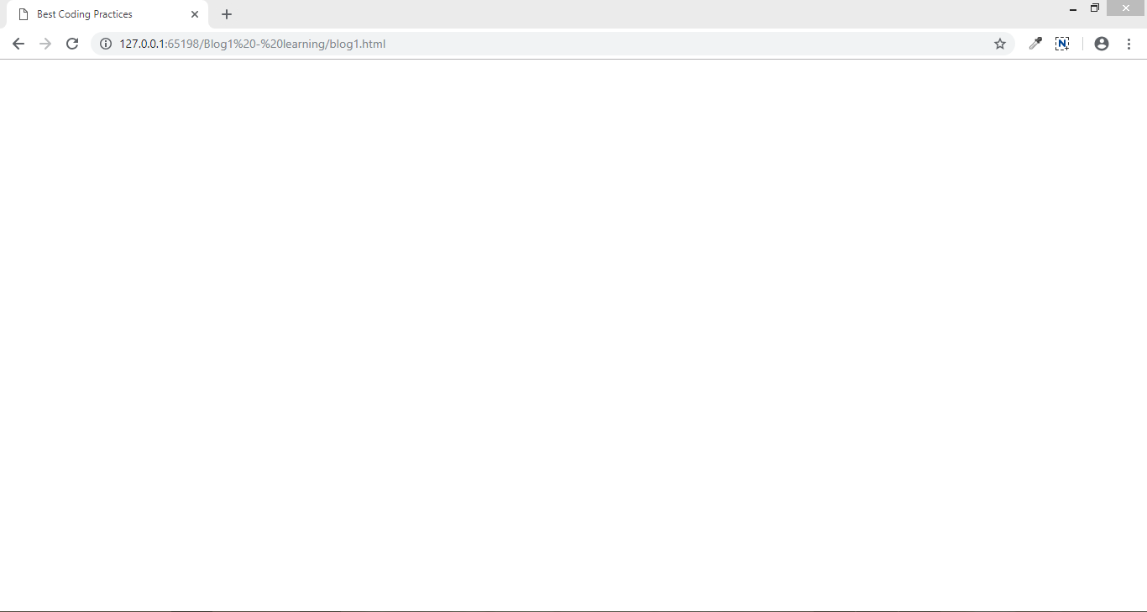](https://ninjasfiles.s3.amazonaws.com/0000000000001390.PNG)